**How to install and run the project**

**Prerequisites:**

In order to run the project you should have installed in you machine

* **SSMS18 Or higher**
* **Visual studio 19**
* **SQL Server 2019 or higher**
* **SQL Server Integration services**

# **How to deploy the Database:**

You have 2 different ways to get the databases in your SQL Server 2019 instance:

1)**Restoring the backup files you find attached**.

2)**Using visual studio**

* Open the **WebAgency** and **DWH** solutions in visual studio 19
* Once the solution is open right click on the Database solution and click publish

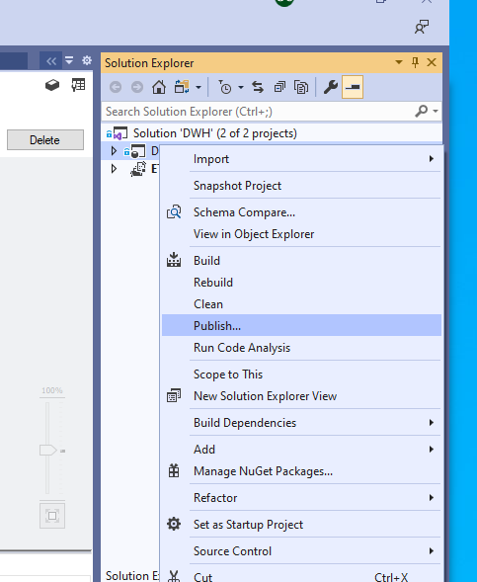

* Once you click publish edit the connection property using your local connection strings

# **How to deploy the SSIS project:**

**1)Using the ETL.ispac file you find attached.**

* Double click on it
* Follow the wizard, connect to your local instance and select the folder. If you do not have any folder create a new one.

**2)You can always deploy the project from visual studio opening the solution.**

**Please bear in mind that if you are deploying the package in a named instance and not a default one you should change the connection string in the project parameters.**

**If you are deploying in a default instance you should not have any problem** otherwise

**1)right click** on the project you deployed and **select configure**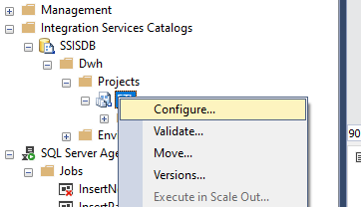

2)Change the datasource property in connection string for both project connection:

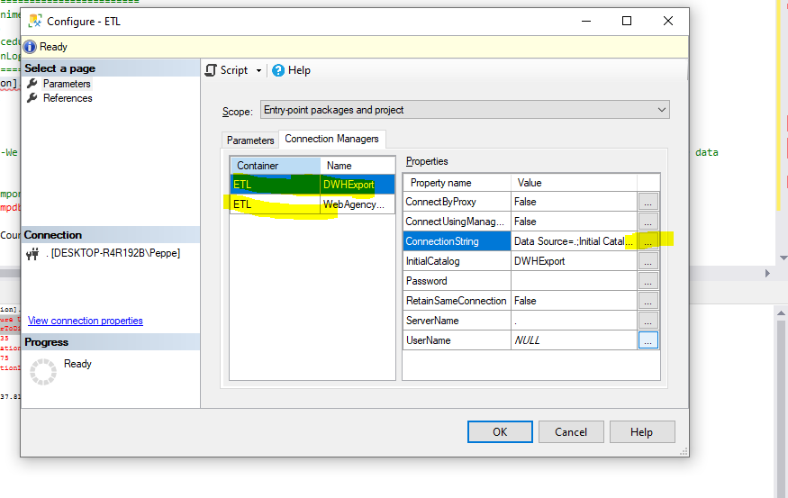

**3)**Click on the 3 dots and change the connection string in according to your named instance

# **How to run an SSIS PACKAGE**

You can run a package using visual studio or directly from the server:

**Run a package from the server**

1)Locate the package you want to run, right click on it end hit Execute

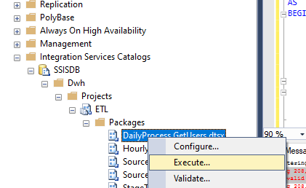

**Run a package from Visual studio**

1)Open the DWH project

2)Right Click on the package you want to run and hit Execute:

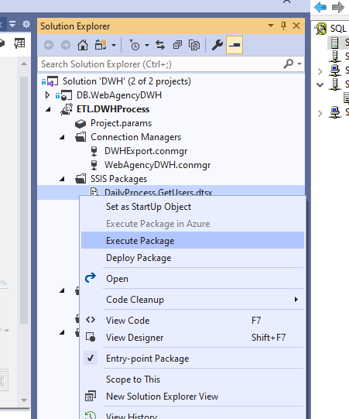

**You have 2 packages you should mainly run:**

1. **DailyProcess.GetUsers** which is the process we will run every day to load the user data
2. **HourlyProcess.GetPages** which is the load of the fact table we will run every hour

**You can run every package in the folder anyway, please reference to the documentation file to understand what they do.**

**Please remember to populate the data in the data source before running the packages, to populate the data you can use the Test procedures I created in the WebAgency DB:**

**[Test].[InsertUserDummyData] <**@NumberOfDummyUsers optional int>

This procedure will insert the specified amount of data into the User Table

**[Test].[InsertPageViewsDummyData] <@**NumberOfDummyPageViews optional int>

This procedure will insert a specified number of record into the PageView Table